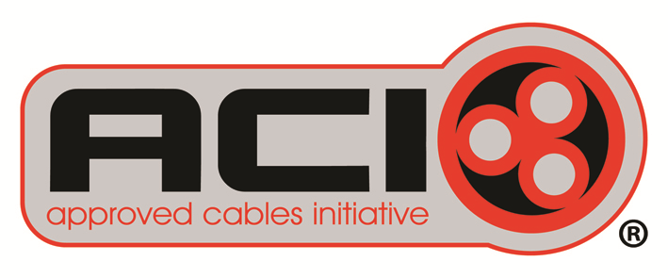

ACI/252/15 1st October 2015

**Re-cast LVD will deliver more accountability**

The Approved Cables Initiative is advising those participating in electrical supply chain (economic operators) that the re-cast Low Voltage Directive* (LVD) comes into force at a national level on 1st April 2016.

The fundamental objective of the new Low Voltage Directive (LVD) is to bring accountability to all “economic operators” intervening in the supply chain and to ensure that products, placed on the market provide the highest level of protection to the user and general public.

While the UK has an obligation under EU law to implement the new legislation and ensure the objectives** of the Directive are met, there has been a choice in how this is done.

Wanting to develop a better understanding on the likely impact of the new Directive, the Department for Business Innovation and Skills (BIS) called last month for comment on their proposed implementation and its approach to penalties and redress. The ACI highlighted the Consultation process which closed on 29th September 2015.

Peter Smeeth, spokesperson for the ACI said: “From talking with industry we feel that the understanding of the re-cast LVD and its implementation is limited. Cable manufacturers, importers and distributors will have specific obligations from spring 2016 and failure to meet these will result in penalties. ”

The implementation of the new LVD means great responsibilities for cable manufacturers and importers.

Manufacturers’ obligations include:

* a need for product instructions and safety information to be provided in a language which is easily understood by consumers and end-users
* products to bear the CE marking*** and be accompanied by the required documents
* name and address of the manufacturer to be indicated on the product or its packaging
* the manufacturer to carry out routine sample testing on products which they have supplied, when this is appropriate, in the light of the risks presented by a product to the health and safety of consumers. It is recommended that the approach to testing is undertaken with due consideration of the requirements defined within EU OJ entry L218 13.8.2008 and 768/2008/EC. If necessary a register of complaints, non-conforming products and product recalls should also be kept and distributors informed about such monitoring.

Importers/Distributors will need to:

* maintain a copy of the manufacturers EU declaration of conformity associated with each product and ensure the supporting technical documentation can be obtained when requested by authorities
* confirm that manufacturers, including those outside the EU, have applied the correct conformity assessment procedure and that documentation is available for inspection by the competent national authority
* confirm that product(s) bear the CE marking and are accompanied by the required documents
* ensure that the name and address of the manufacturer or importer is indicated on the products or the packaging
* undertake routine sample testing and product monitoring as it applies to manufacturers, including the requirements defined within EU OJ entry L218 13.8.2008 and 768/2008/EC
* Ensure traceability is maintained throughout the whole supply chain

Peter Smeeth continued: “From April next year responsibilities will go much further than the original Directive. We still believe traceability to be at the forefront of eliminating substandard cable and we know UK cable manufacturers are doing, and will do, their utmost to ensure that such traceability can be fulfilled.

“We reiterate that this can be made a much simpler process by making sure that reasonable marking including the name of the manufacturer/importer/distributor, the number of a relevant national, European or international standard, any recognised coding and a year/date of manufacture is all detailed. Where manufacturers are unsure about cable marking they should contact the ACI for clarification.”

The Approved Cables Initiative last year updated its cable marking guide which can be downloaded from the website. If you have any concerns regarding sub-standard, defective or faulty cable, the ACI can be contacted on 0208 946 6978/07973 636688 or you can email [info@aci.org.uk](mailto:info@aci.org.uk) .

For further information about the ACI campaign visit [www.aci.org.uk](http://www.aci.org.uk)

ENDS

*\*The Low Voltage Directive provides common broad objectives for electrical safety regulations, and covers all electrical equipment and components designed for use with a voltage rating of between 50 and 1000 V for alternating current and between 75 and 1500 V for direct current. The revised LVD (2014/35/EU) will be released in UK as a revision of the Electrical Equipment (Safety) Regulations.*

*\*\* The primary objectives of the revised legislation are to ensure that:*

* *Legislation governing products should be clear and more consistent across sectors*
* *Obligations of all economic operators in the supply chain should be is set out in more detail*
* *Provision should be made to ensure that products are more traceable*
* *Those bodies which carry out conformity assessments should have certain attributes (e.g. independence and capability) and certain operational obligations*
* *Each Member State should have robust, but proportionate, market surveillance and enforcement mechanisms in place based on a set of common requirements at the EU level.*

***The *British Cables Association and Europacable have both agreed that for many cables, for technical and related reasons, it is preferable the CE Marking is placed on the reel, drum and/or documentation.*